1. SCREEN 1_ PATIENT REGISTRATION PAGE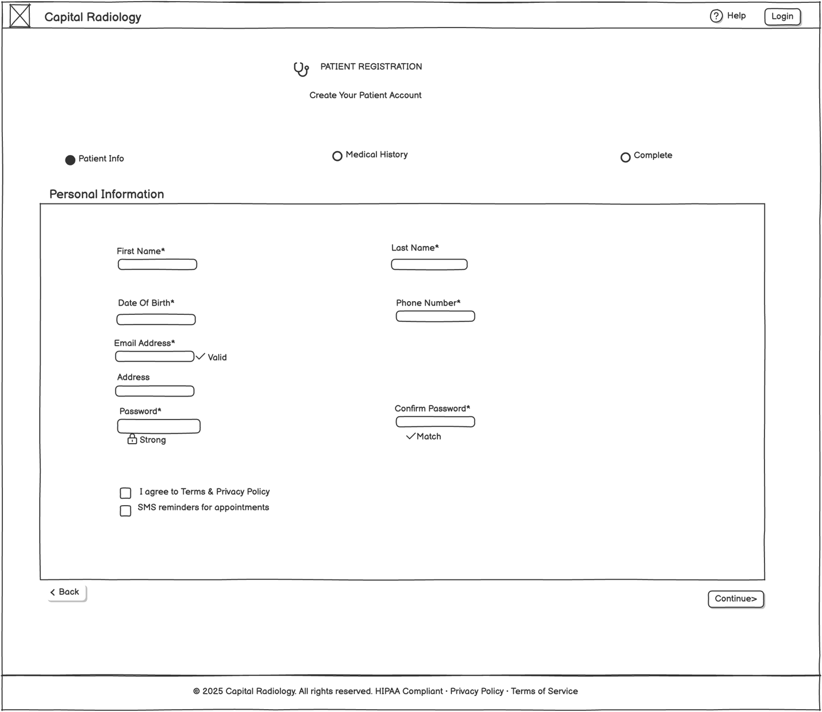

2. SCREEN 2_ PATIENT HELP_FAQ PORTAL

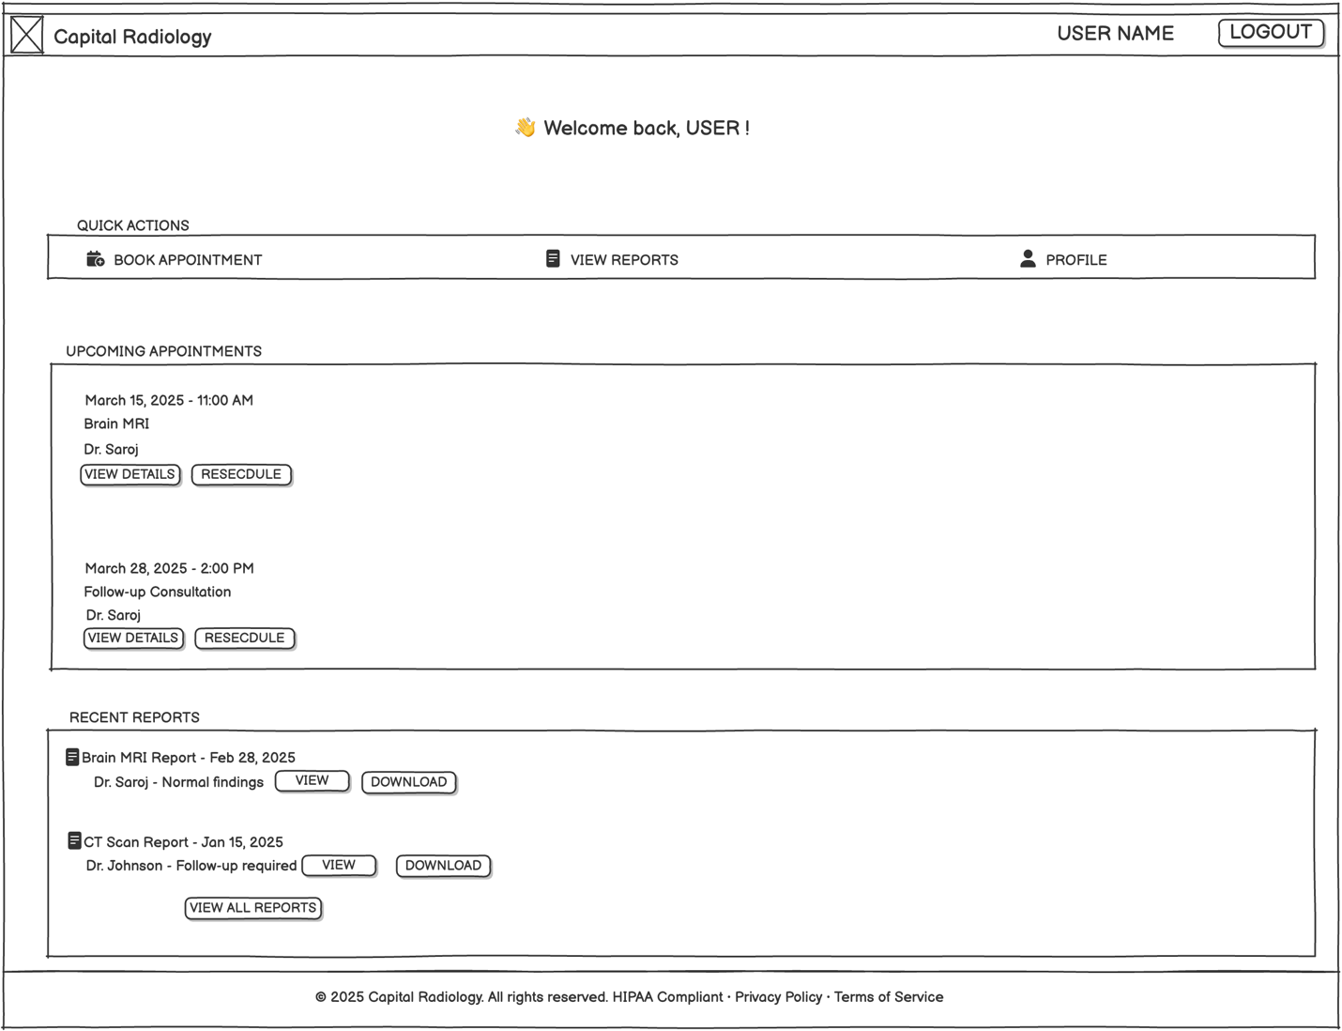

3. SCREEN 3_ PATIENT DASHBOARD



4. SCREEN 4_ MRI REPORT VIEWER

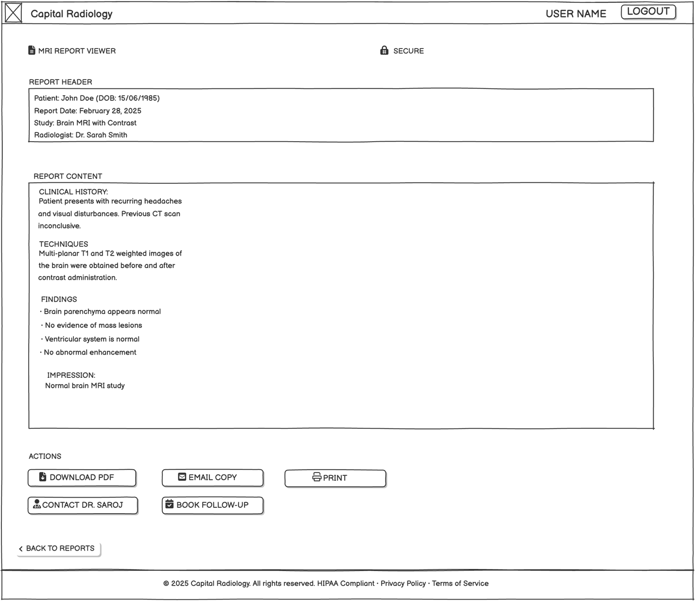

5. INPUT FORM 1_ PATIENT REGISTRATION FORM

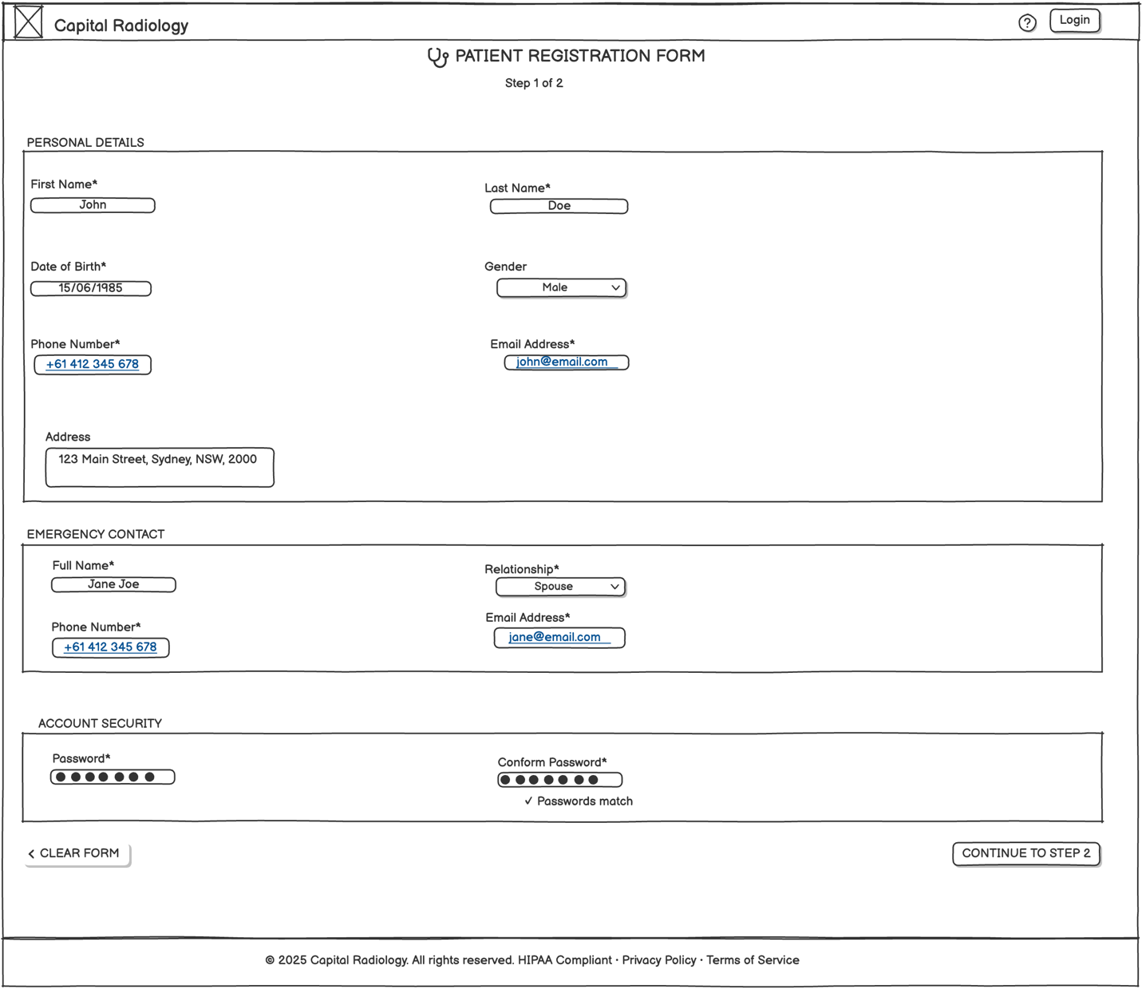

6. INPUT FORM 2_ MEDICAL HISTORY FORM

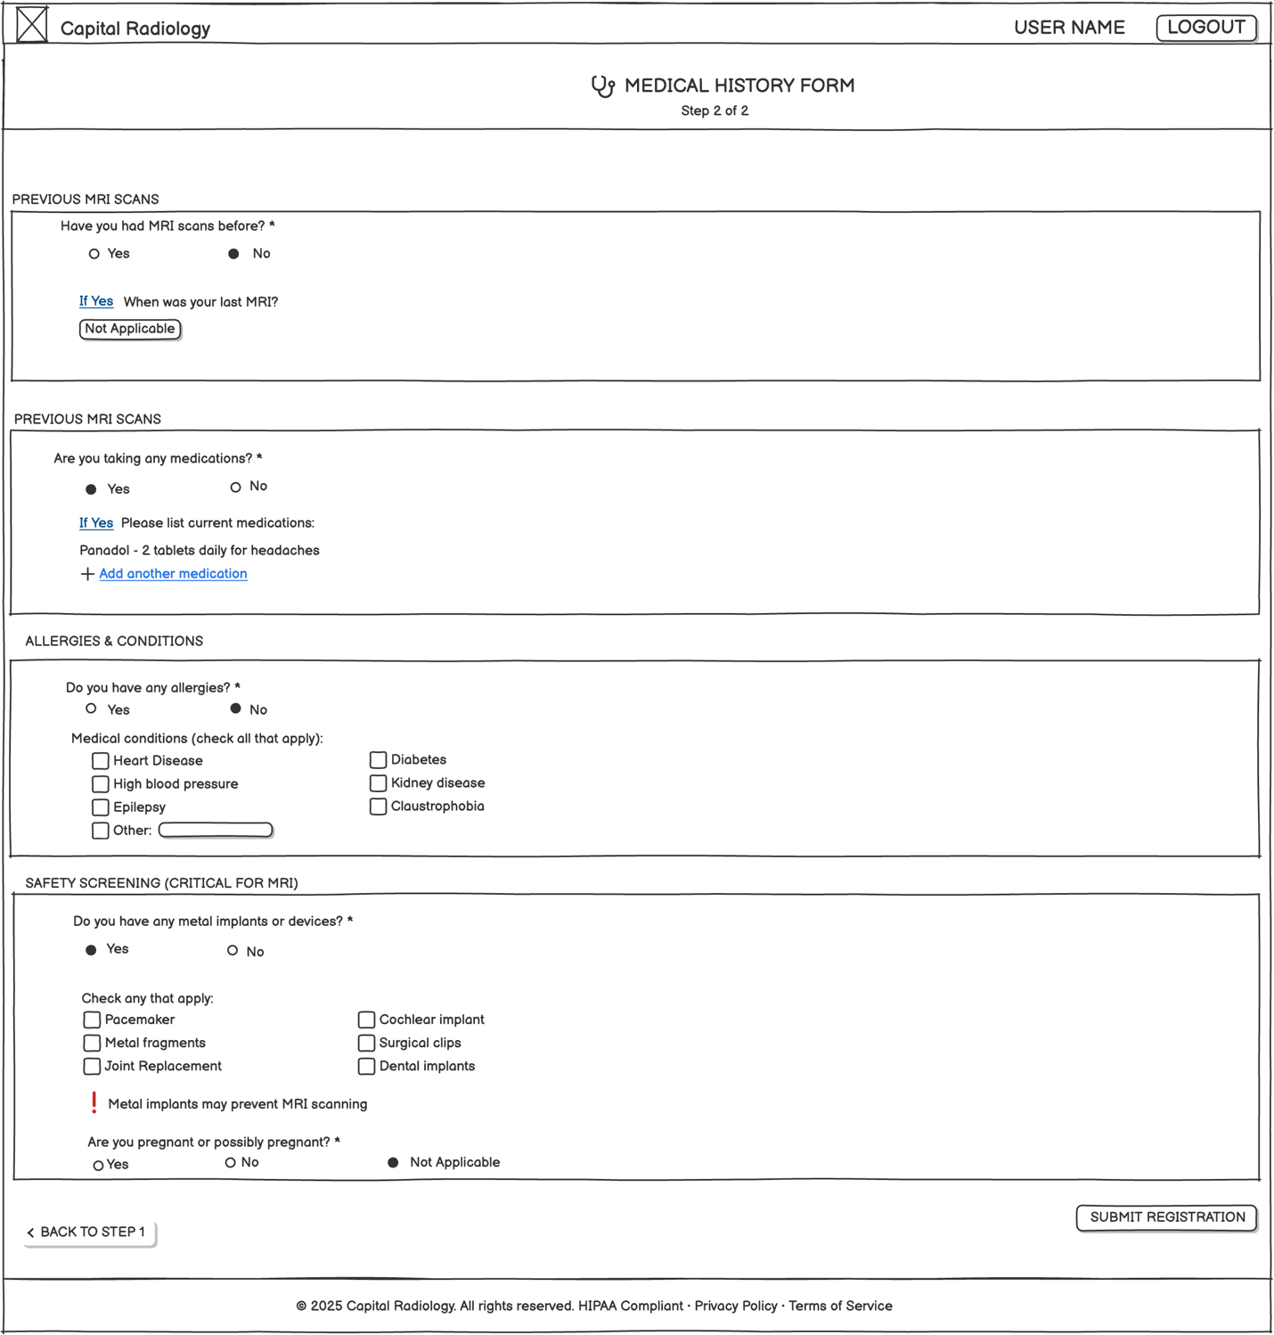

7.OUTPUT FORM_1 MEDICAL SUMMARY REPORT

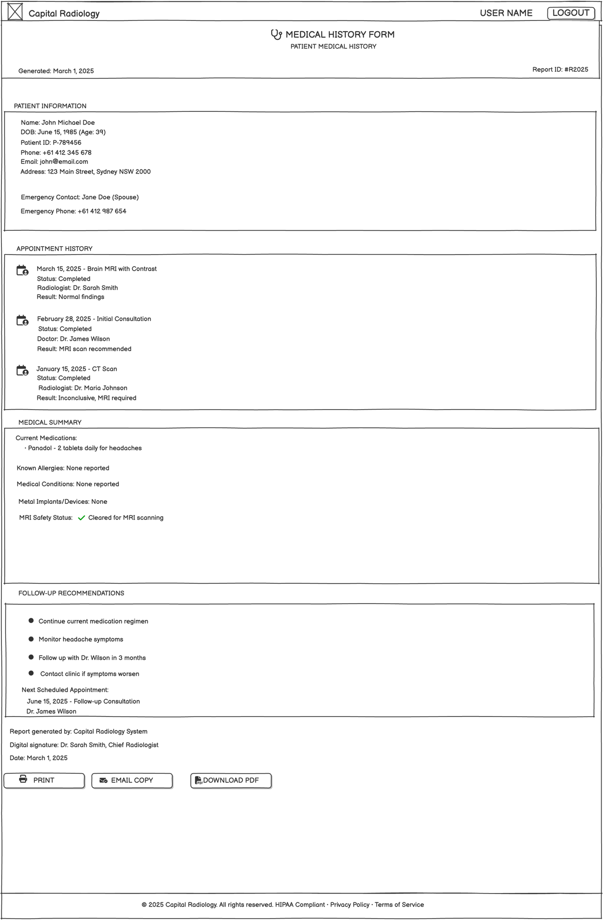

8. OUTPUT FORM 2_ APPOINTMENT CONFIRMATION

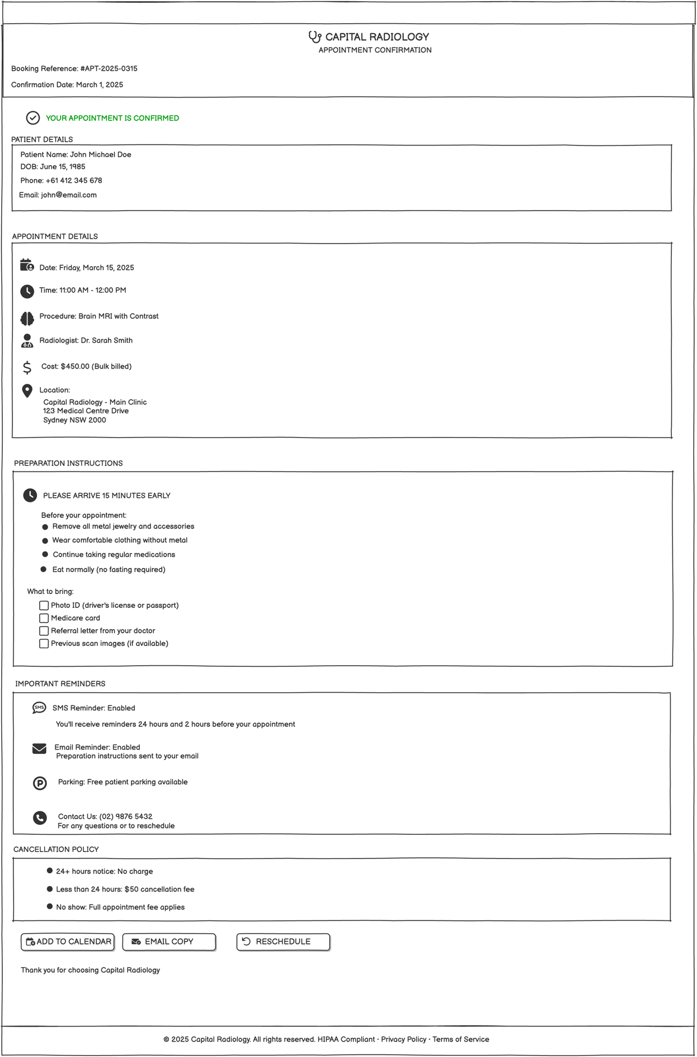

9. 4-STEP USER FLOW: PATENT SUPPORT ND ENGAGE

